Oconee River Trip 2:
(November 6th – 10th, 2019)
Jimmy Thompson (Jackson Cuda 14’)
Eric Jackson (Jackson Cuda 14’)
Jamie Brack (Wilderness Systems Tsunami 145)
Tim Spain (Liquid Logic Manta Ray XT 12)

Buckeye Landing – Dublin Highway 221 Bridge - Uvalda
(76.50 miles)

Day 1: (Wednesday) 21.75 miles
Awoke: 0500hrs
Breakfast: 0745hrs
Embarked: 0830hrs
Break: None
Lunch: 1200-1215hrs (on sandbar)
Break: None
Ending Time: 1515hrs
Dinner: 1700hrs
Sleep Time: 2030hrs
- Everyone met the morning of launch at my home except for Jamie who met us at the launch along with his parents who will shuttle/secure our vehicles while we paddle. The Brack family are tremendous and always lend a helping hand.
- It was an easy drive down to Dublin which was surprisingly more so than to Abbeville which may open up options for future “Oconee River Runs”.
- Mr. Brack led us in prayer prior to our launch.
- I was initially very concerned about the low water levels (1.5’ at the Dublin gauge) exposing rocks and creating issues for our journey but thankfully the water bypassed them.
- We were off to an amazing start having gotten onto the water on time at 0830hrs.
- The river was slow compared to previous rivers and even the Oconee on the previous Expedition. Thankfully the tailwind was swift which compensated for the slow current.
- We made it to mile marker 16 which was our daily minimum and decided to push on a little bit further in an effort to get ahead of the mileage. This provides us with a cushion in the event we experienced poor weather, a shorter last day, or if we all just wanted to sleep in one day.
- We all made it to mile 21.75 around 1515hrs and camped on a very large sandbar located on the River Bend WMA.
- Rookie mistake-1 on my part… I forgot to bring a back-up fuel cell for my single burner stove. Although it’s extremely efficient, if there isn’t any fuel in the canister you can’t really be but so efficient. As usual everyone was willing chip in and ensure nobody did without.
- Rookie mistake-2 on my part… I didn’t check the expiration date on my potato chips only to realize they smelled like varnish having expired in 2016! Yuck!!!
- Jamie brought smoked thick-cut pork chops that we warmed over some coals on the camp grill. He bought enough for each of us to get one, they were fantastic and tasted like country ham. Yum!!!
- I then cooked up some hotdogs in my frying pan and they made a hearty meal.
- We made a small campfire and reflected on the day prior to going to bed.

Sunrise: 0616hrs
Air Temp: 60-77° average
Water Temp: 58°
Barometer: 1037
Wind Speed: 1-5mph (Northwest)
Water Gauge: 1.5’
Drift Speed: 1.25mph
Water Clarity: 2’
Cloud Cover: Clear
Sunset: 1802hrs

Day 2: (Thursday) 17.25 miles, 39 miles overall
Awoke: 0630hrs
Breakfast: 0715hrs
Embarked: 0830hrs
Break: None
Lunch: 1200-1230hrs (on sandbar)
Break: None
Ending Time: 1400hrs
Dinner: 1700hrs
Sleep Time: 2300hrs
- Per usual, the dew on the river is a force to reckon with. It was as though it had rained. We all begrudgingly packed up wet and sandy gear in our bags. We hope to reach camp early enough to dry everything out.
- We were all on the water at 0830hrs which is just a little earlier than we usually launch closer to 0845-0900hrs. Every 15 minutes essentially is another mile down river we could be so it all adds up.
- The river hadn’t changed any as of yet and was still slow. The wind wasn’t very noticeable either.
- The Oconee River is remarkably similar in appearance and topography to the Ocmulgee. It’s no surprise as they’re considered “sisters”. The river did eventually lend itself to having sandbars around every 2-3 turns which allows you to really pick a suitable campsite.
- We stopped for lunch on a sandbar and everybody welcomed the leg stretching. We reviewed the map and decided we all wanted to have a shorter day today compared to yesterday’s 21.75 miles so we all agreed to hit the daily minimum of 16 and then start shopping for a campsite.
- We saw only two boats on this segment of the river. Each were friendly and didn’t seem to be really catching much.
- One very neat thing that I hadn’t seen before today was a doe swimming across the river. I hope I got some good footage of it. We then saw a good sized buck on a sandbar.
- We wrapped up the day on a beautiful broad turn in the river which revealed a very large cypress tree across the river. The sandbar was vast and we gathered a good bit of wood so we could have a nice campfire that night.
- Everyone was glad to dry out their gear from the morning dew.
- At one point we saw a small airplane above. The airplane obviously saw us and did an acrobatic descending loop only to return minutes later dipping its oversized tires into the river!!! It was very cool to see such skill and we all really appreciated the exhibition.
- Rookie mistake-3 on my part… During the airshow I grabbed my iphone and recorded the event or so I thought. Apparently I fat-fingered the record button and only got our cheering and accolades following the aerial display. What a huge disappointment. The other guys made good use of the goof and reminded me several times about how exciting that would’ve been in the video.
- The weather forecast was calling for considerable rain overnight but with only 7mph wind. I decided to huddle up near a tree and use it as a tie-off for my tarp to give us a place to shield a lot of our gear.
- Rookie mistake-4 on my part… I couldn’t find my mash bag of tarp rigging! I have about 25 adjustable Cam-Jam hooks attached to 550 cord with a figure-9 cleat used as a ridgeline along with some small metal stakes. Essentially everything I needed to secure the tarp. Thankfully Jamie had some nylon rope and I cannibalized the 550 cord on my bowline to tie off the tarp as best I could to some sharpened limbs into the sand. Needless to say I was not a happy camper and the whereabouts of my rigging bag was on my mind most of the night.
- The rest of the night was spent relaxing by the fire. I finished up the pack of hotdogs for dinner.
- At 0100hrs I was abruptly awoken by the sound of a loose tarp whipping through the wind onto the top of my tent and the sound of heavy rain! Though I had my rainfly on the tent I did leave the side open for airflow and to receive the cool air. I had to quickly retrieve my “Tacti-Cool Milk Crate©” which my GoPro-5 was set to time-lapse night shot for the video. I pulled it under the vestibule of my tent and zipped the rain fly all the way closed. It sure is hard to get back to sleep when your bare chest gets hit with 15-20mph wind & rain. So much for the forecasted 7mph.

Sunrise: 0617hrs
Air Temp: 58-67° average
Water Temp: 58°
Barometer: 1035
Wind Speed: 1-5mph (Northwest)
Water Gauge: 1.5’’
Drift Speed: 1.5mph
Water Clarity: 2’
Cloud Cover: Cloudy
Sunset: 1801hrs

Day 3: (Friday) 15.75 miles, 54.75 miles overall
Awoke: 0630hrs
Breakfast: 0730hrs
Embarked: 0800
Break: None
Lunch: 1400hrs (In camp)
Break: None
Ending Time: 1215hrs
Dinner: 1730hrs
Sleep Time: 2100hrs
- Once again the dew struck!
- We constantly review the weather and knew it would be chilly tonight. We all wanted to ensure we had enough wood to really make a good fire. We checked the map and agreed to make it an even shorter day than yesterday. We sure we’re thankful we logged so many miles on the first day. That extra effort really allowed us a lot of flexibility.
- Jamie and I remarked at how beautiful this section of river was and how we’d both like to paddle this segment again with beginners. This part of the river had a multitude of sights: trestle-bridge, road-bridge, curves, straightaways, and given proper water levels some very small whitewater (less than Class-1).
- We found a good sized sandbar to call home for the night.
- The weather forecasted a 39° morning so we definitely knew we’d need a lot of wood especially if it was punky and decayed as the previous campsite yielded.
- As we walked around gathering wood we kept a close eye on the ground. I told the guys about my finding a very old wooden paddle and a Clovis point on my two previous trips.
- Jamie found a shard of flint-stone that was razor sharp. There wasn’t any other flint in the area and one could only imagine it being left there by someone years ago.
- Eric found a sizeable piece of pottery about 3.5”x2” in size. It had a series of non-intersecting diagonal lines that essentially formed a line of “stacked V’s”.
- I found a small piece of pottery about 2”x1” in size and some pink colored rocks to bring home to my girls for a souvenir.
- We enjoyed a nice warm fire that evening having found a tremendous amount of dense deadfall. Throughout the night we heard sounds of hogs, owls, and coyotes in the distance. They really are a pleasant sound to hear out in the wild.
- I broke out by chopped steak marinated in teriyaki and some instant mashed potatoes. Later that evening I cooked some Maruchan instant noodles that really warmed me up before bedtime.

Sunrise: 0617hrs
Air Temp: 44-60° average
Water Temp: 58°
Barometer: 1032
Wind Speed: 8mph (Northwest)
Water Gauge: 7’
Drift Speed: 1.75 mph
Water Clarity: 2’
Cloud Cover: Cloudy
Sunset: 1801hrs

Day 4: (Saturday) 10.25 miles, 65 miles overall
Awoke: 0630hrs
Breakfast: 00730hrs
Embarked: 0900hrs
Break: None
Lunch: 1400hrs (In camp)
Break: None
Ending Time: 1130hrs
Dinner: 1800hrs
Sleep Time: 2300hrs
- We were all disappointed that the cold weather didn’t dispel the morning dew that has plagued us the entire trip. We now had the luxury of frost on much of our gear. I’d still rather have that than 95° temperatures!
- Our morning briefing consisted of some chiding as we were all becoming more comfortable with one another’s sense of humor. We also discussed how cold the night ahead of us would be with a forecasted dip.
- Given our excellent progress not only in overall paddled mileage but also the noticeable increase in average speed (our normal average speed is 3.3mph whereas we have a 3.6mph average for this trip) we knew if we didn’t either slow down or lay-up super-early for the day that we’d wind up reaching the extraction a day early. We decided to follow the idea of cashing in the miles on the last day and leave about 10 miles for the last day. I knew of several sandbars that lead up to mile marker 70 on the map but there wasn’t much beyond that point.
- Once we got past the 10 mile mark for the day we decided to start shopping for a great spot. This was to be our last evening on the Oconee River and for me the culmination of 5 years of paddling this watershed having already paddled the Altamaha & Ocmulgee Rivers.
- We stopped and scouted a sandbar that had a large piece of birch deadfall on it very close to where we’d like to camp. Unfortunately we also noticed a good bit of tire tracks on the sandbar. Since it was Saturday night we opted to push on in lieu of possibly meeting some joyriders in the middle of the night.
- Just around the next bend we found a half-mile long sandbar with several dead trees which were easily retrievable and no tire tracks!
- We all remarked how funny it felt to make camp prior to noon but were again glad to have the chance to air out soaking wet gear.
- After piling up a huge amount of firewood we all had some private time. Jamie went for a walk down river and wound up napping in the warm sand, I walked around to see if I could find any relics, Eric piddled around camp, and Tim remained near the camp as well. Eventually Eric, Tim, and I all went walking down river past Jamie as we followed a streak of exposed river rock on the sandbar which in my experience yields the best finds.
- I saw some fresh deer tracks and decided to follow them across the sandbar for about 100 yards. The sandbar turned into more of a peninsula at this point with a slough to the left and the river to the right. I looked ahead of where the deer tracks were and saw an oddly yet familiar shaped piece of wood along the slough. As I walked past and looked right I noticed the back of the log appeared to be shaped similar to a keeled-stern and immediately walked into the muddy bottom to check it out. As I got closer the log appeared to have a flat edge and rolled sides tapering on the opposite end of what resembled a stern. I could see some holes in the side of the log and viewed in the best I could and determined the log was hollowed out. My excitement was immense and I called out to both Eric & Tim “Guys… You’re not going to believe this.”. They joined me in the muddy bottom and together we began examining the log. Each of us agreed it should be rolled over to see what in fact it was. We ran our fingers along the edges and felt they formed an edge opposite the flat portion of the log. Eric lifted the stern shaped end and remarked at its weight, it was HEAVY!
- I hustled back to camp to get Jaime who is an engineer to whom we felt it best to follow his judgment regarding the structural integrity. He suggested we knock on portions of the log to see if it sounded solid enough to move… It was rock solid! We put two cut limbs beside the log for it to roll onto. We each grabbed a part of the log and rolled it over which revealed it was in fact hollowed out in a fashion that resembled a dugout canoe!
- High fives all around and a lot of good cheers and chills. We had found a 17’ log that appeared to have been hand-hewn that was in reasonably good shape.
- We knew with the river being so low that any rise would surely take the find away. We didn’t want to risk either it’s disappearance or to further damage it. We knew we have to recover the log as people simply needed to see this as a part of Georgia history.
- First things first we needed a plan. Neither of us had access to a motorized boat at the time and we couldn’t babysit the dugout until someone was able to arrive on scene. We determined it would be the best option give the aforementioned to “float it out”. We devised a plan to position the dugout on the sandbar and elevate it off the sand to help dry it out and aid in buoyancy. Then we’d return to the dugout the following morning and wrap a tarp under the dugout and lace the grommets together using cordage. I figured I could paddle alongside the dugout with my right foot on the port side to counter balance it enough to raise the rotted holes on the starboard side extend well above the waterline. This combined with Jamie scouting the river for the deepest route and Tim as the tow boat since he didn’t have a rudder to obstruct the tow line is exactly what we did with Eric and I as rudders swapping out a couple of times.
- We left the dugout on raised off the sandbar and returned to camp in complete and utter awe.
- Jamie led us in prayer for safe passage and protection for the following day.
- We spent the rest of the night shaking our heads and pondering the dugout’s origins.

Sunrise: 0617hrs
Air Temp: 39-60° average
Water Temp: 58°
Barometer: 1013
Wind Speed: 6mph (North)
Water Gauge: 2.0’
Drift Speed: 1.75mph
Water Clarity: 2’
Cloud Cover: Clear
Sunset: 1801hrs

Day 5: (Sunday) 11.50 miles, 76.50 miles overall
Awoke: 0630hrs
Breakfast: 0715hrs
Embarked: 0900hrs
Break: None
Lunch: 1400hrs (Popeye’s Chicken in Hazlehurst)
Break: None
Ending Time: 1300hrs
Dinner: None
Sleep Time: None
- We awoke to frost on everything! It was 34° with no wind thankfully.
- I was actually surprised how calm everyone was given the magnitude of what lay ahead of us. We jokingly commented on how tragic it would be if somehow it dugout was discovered overnight by someone and taken. This wasn’t the case. We paddled to the far end of the sandbar and there she was with steam coming off of her as she warmed in the morning light.
- We gingerly placed the dugout into the river and began our return.
- The plan worked flawlessly. After a few miles of paddling we were able to extract the recovered dugout and place it onto a flatbed trailer nestled in a thick bed of pine straw. It was as amazing as it was humbling.
- I’ve since spoken to numerous professionals in my attempt to get this thing in public view.
- With only a few miles left for the Expedition we gladly paddled it without the burden of the dugout. We extracted having not taken time for lunch and were all extremely hungry. We drove to Hazlehurst and I finally wrapped my lips around one of those spicy chicken sandwiches that are all the rave, two in fact.
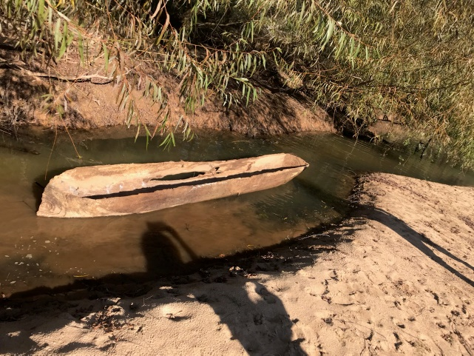
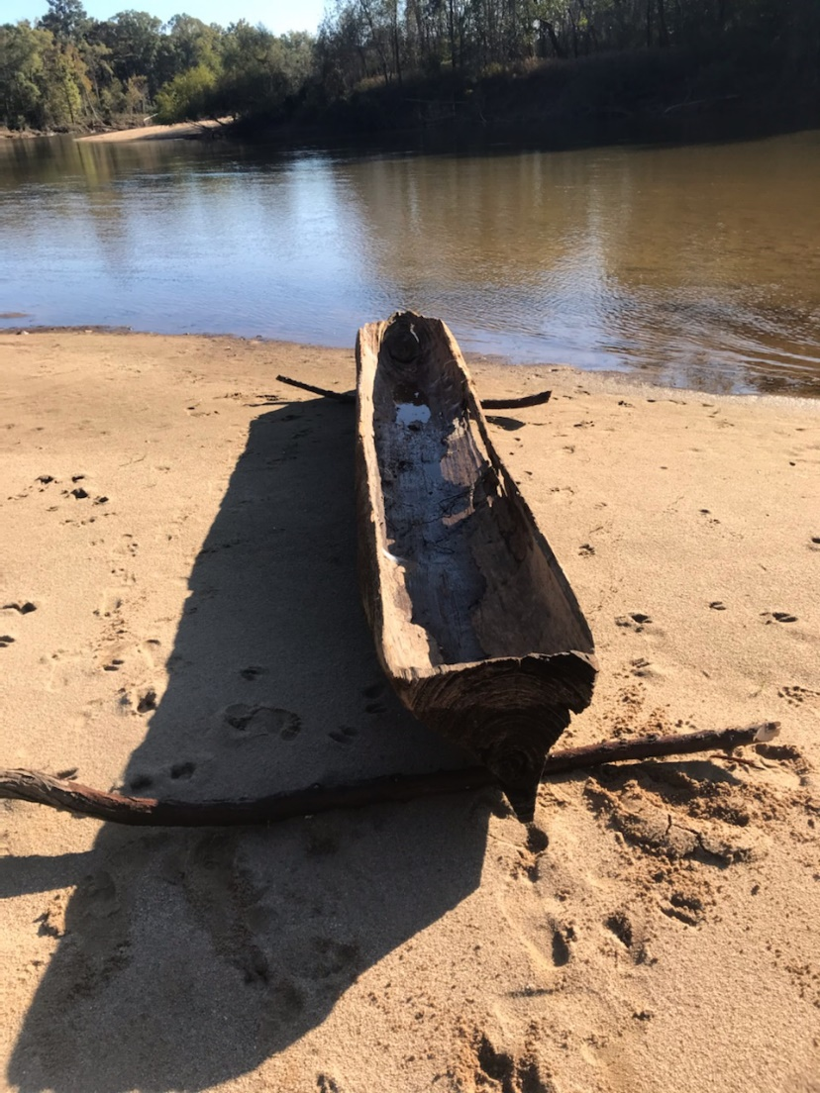
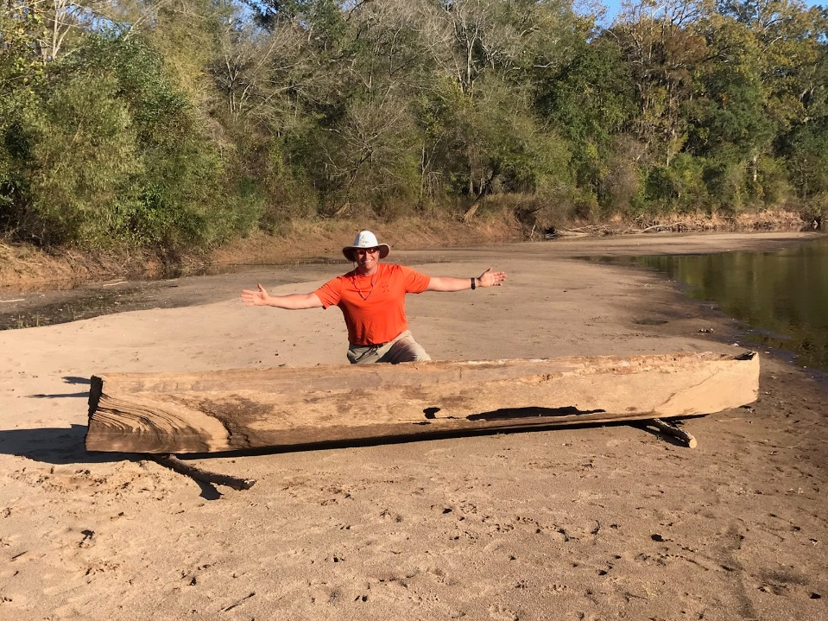
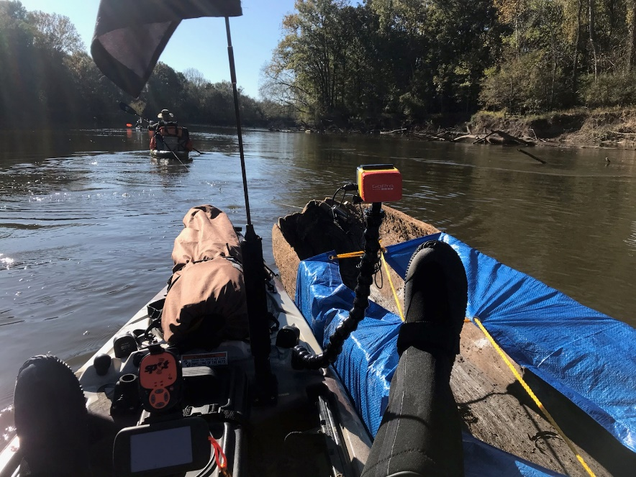
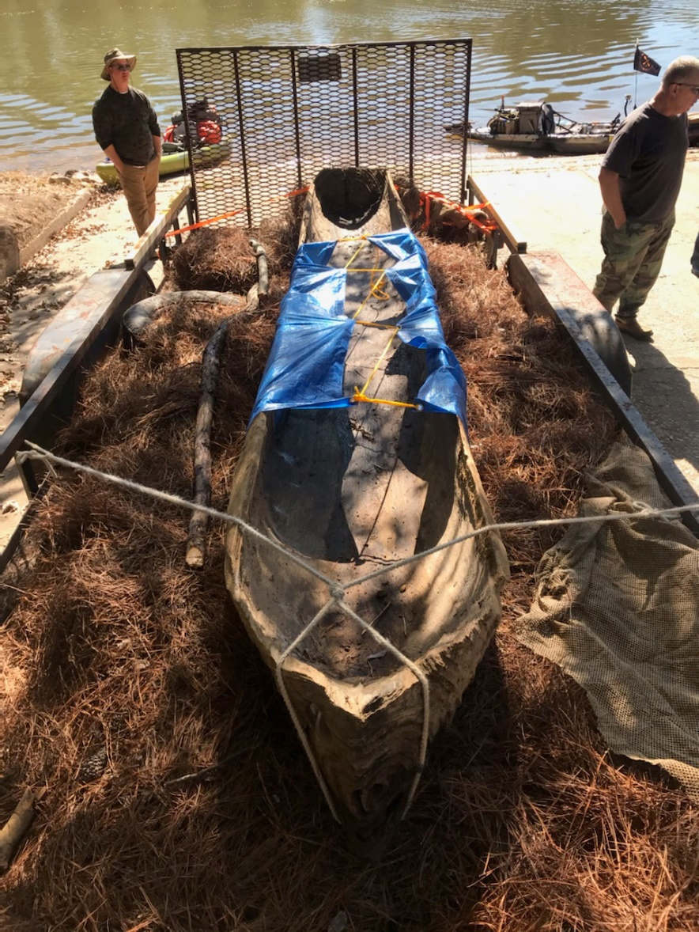

Sunrise: 0617hrs
Air Temp: 34-60° average
Water Temp: 57°
Barometer: 1013
Wind Speed: 1mph (North)
Water Gauge: 2.0’
Drift Speed: 1.75mph
Water Clarity: 2’
Cloud Cover: Clear
Sunset: 1801hrs
Conclusion:
This Expedition was a really one for the record books! Although the discovery of the dugout eclipses everything else we experienced, the river was a sight to behold. The biggest factor in the success of our journey was the presence of a tailwind. Without this the 3.6mph daily average speed would surely be closer to at-best 3mph. This section of the river didn’t seem to be affected much by the overnight rainfall experienced on night #3. The scenery was comparable to what we’ve seen in the past mainly due to the foliage & topography. We averaged 15.3 miles a day as we paddled down the river totaling 76.5 miles. The Expedition initially was billed as an 80 mile trip but with many turns and a significant oxbow cut that we were able to make the mileage did lower. Also, we found it best to camp on areas of the sandbar that had exposed pebbles as opposed to actual sand. We all had a ground pad of some kind which negated any cushioning the sand may offer so the benefit is in the morning your wet gear isn’t as sandy. I purchased some NRS Boundary shoes/boots which were much more comfortable than my Muck Boots, easier to take on/off, and warmer albeit my feet did sweat some in the wool socks I wore. The biggest take away for me was to not get complacent in the planning process. I shouldn’t have made those “rookie mistakes” but all in all if those were the worse things I had to encounter it truly was a successful trip.

Things to do differently…
- Don’t get complacent with “rookie mistakes” food preparations, equipment loading (I found the bag of rigging inside my kayak once I unloaded it at home), and necessary gear can make or break a trip. I got lucky.
- Don’t try and shortcut battery provisions. I opted to not bring my solar panel which normally tops-off my 12v battery used to power my GPS & GoPro batteries as needed. It ran out of juice on day #5 and I was lucky enough to get the trip logged with its internal battery.
- Never ever buy Old Smokey Moonshine again… It was horrendous.

